Contents

Specification Import Export – Users Guide 1

Introduction 1

Workflow 1

Work area 1

Selecting a Specification 1

Export 3

Import 5

Layout of the imported/exported file 6

# Specification Import Export – Users Guide

## Introduction

The specification import and export is a self-sufficient web page that can be hosted in inRiver iPMC as a e.g. Application Template, Portal Template, etc. Its function is as the name applies a specification import or export of specification fields.

## Workflow

### Work area

The first thing that needs to be set up in Enrich is a work area, Private or Common Shared. The work area is used because it is a powerful way to select entities with the desired templates.

### Selecting a Specification

Once the work areas are set up the work area can be selected in the first step in the Specification Import Export template.

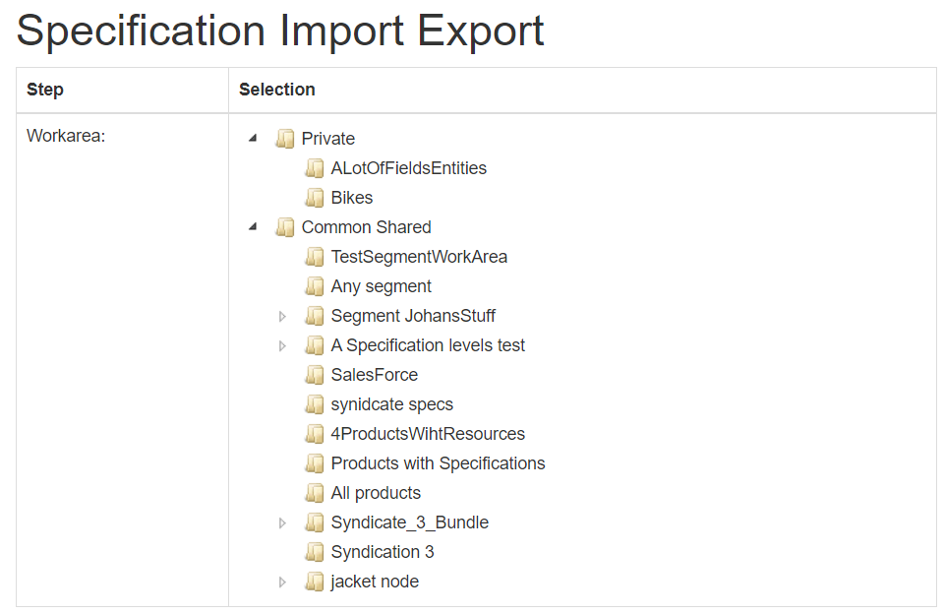

Once a work area is selected the next step is to select which Specification template you want to make an import or export.

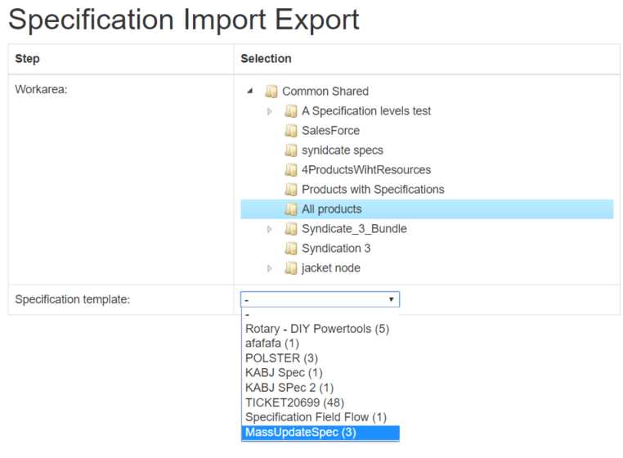

In this case the work area “All products” contains entities (Products) that have the listed Specification templates defined on them. The number within parentheses are the number of entities that are included in that specific Specification template.

When selecting a work area, a download of all entities of that work area is started in the background. This will cause the “Specification template:” drop down to update while downloading.

**Note!** That during the download no import/export can be done. If there is lot of entities to be downloaded this may take a while. A progress indication is presented near the Import/Export buttons.

### Export

Once the template is selected the fields of that template is shown with checkboxes.

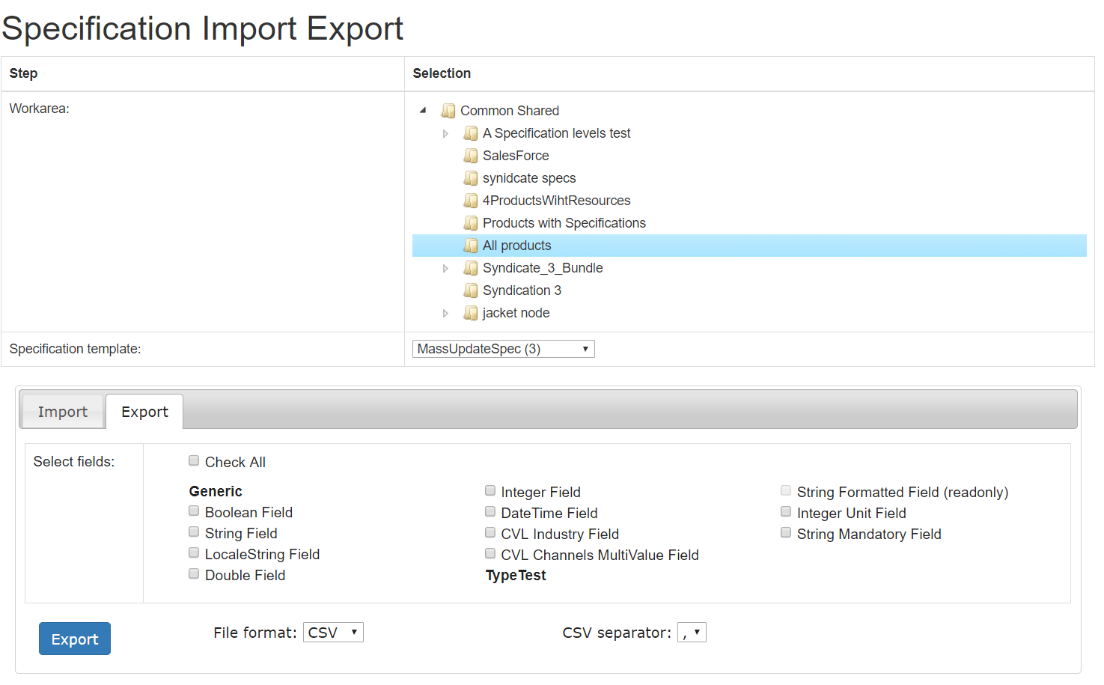

Each Specification template field name is listed under “Selected fields:”. In the above picture the fields have been named in order to identify the DataType used for each field. So, in Enrich the above selected Specification template is looking like this:

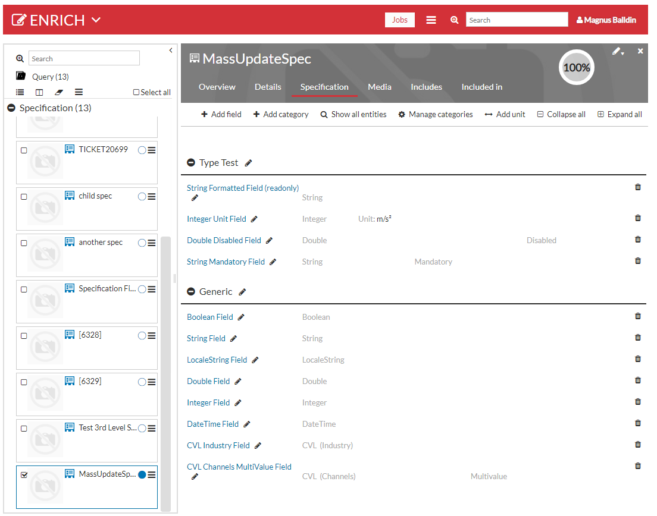

Select (by checking) the fields you want to export. Also, all fields can be selected at the same time by checking the field Check All.

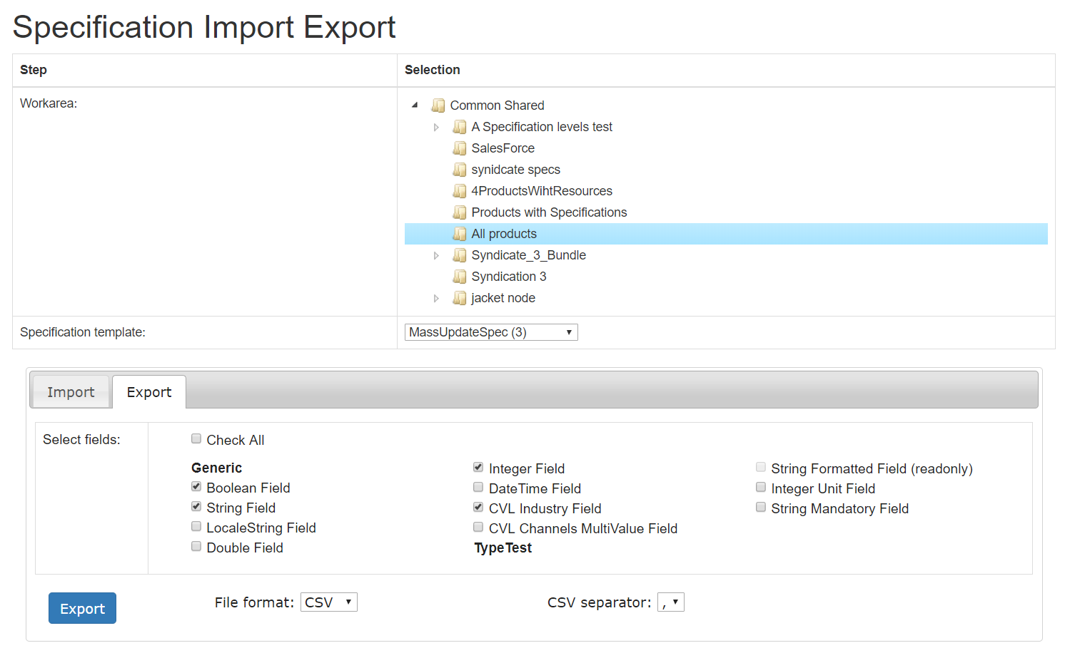

Fill in the fields and click the “Export”. When clicking the button each of the (3) entities that are included in that specification template will be exported to a, in this case, a CSV-file. The CSV file will be separated by a comma (,) as set in the “CSV separator:” drop down. Semicolon can also be selected as a field separator.

XLSX (a format for Microsoft Excel) can also be selected in the “File format:” drop down.

### Import

To import a file just select the Import tab.

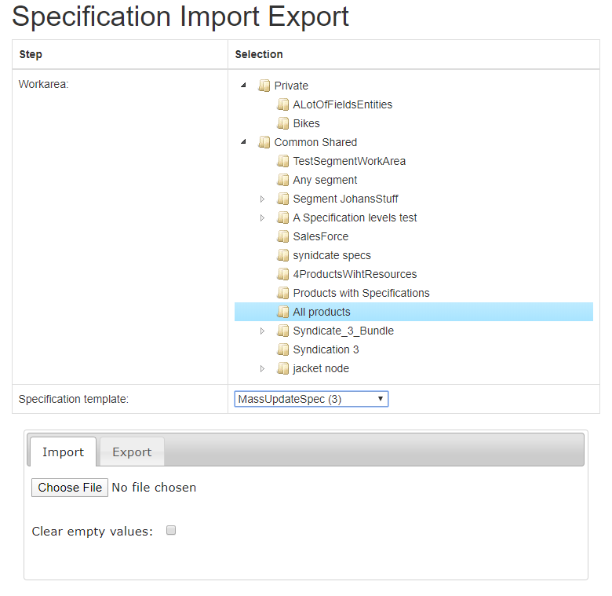

The “Choose File”. As soon as you have chosen a file the import will start. Import means that for the chosen Specification template, specification fields will be updated per row in the field on an Entity level.

The “**Clear empty values:**”-checkbox is used to clear a value. If the checkbox is:

* **Checked** and the value is left empty in the imported file that specific specification field for that specific entity will be **cleared**.
* **Not checked** and the value is left empty in the imported file that specific specification field for that specific entity will be **left as is**.

## Layout of the imported/exported file

Export is done to either a csv file or an excel file hence the file contents is a table of data where the first line is the header. The other lines in the table is one Entity per row.

Import is taking the exported file (that you can edit to your liking (following certain rules)) and updates it in order to update specification fields with the contents of the file.

An example of a file can look like this.



There are some rules that must be followed when it comes to the header. The first three columns must be EntityId, ProductNumber and SpecificationName.

* Under the EntityId the system id of the Entity must be specified.
* Under the SpecificationName header the Specification template selected must be spcified. All items under the SpecificationName column must be the same.

The other columns to the right of EntityId and SpecificationName must be the same as the Specification Field name.

For LocaleString there is a column for each language. It must follow the naming convention ‘FieldName_LanguageAbreviation’ e.g. LocaleString Field_en. See following example:



There is validation of each field imported. See the example below:

